KORONGATA MARAE AGM
& MARAE TRUSTEE RE-ELECTIONS

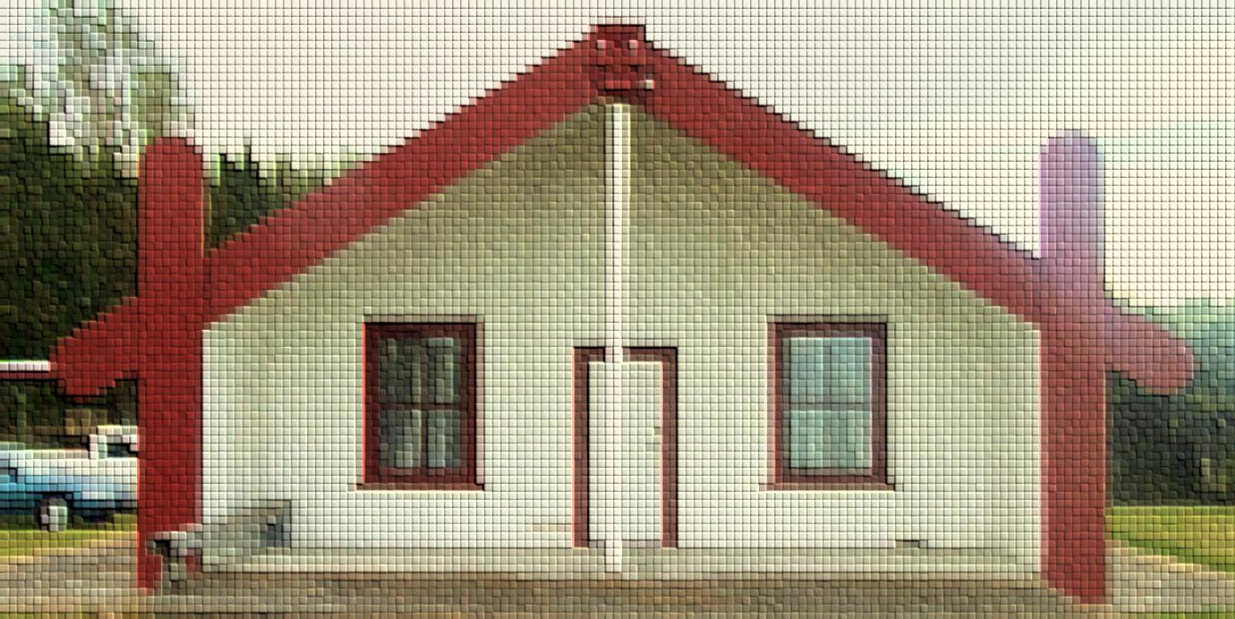

Tuesday 25 April 2017, 10am,
AGENDA
Mihi/Karakia
Call for apologies
Minutes of last AGM
Trustee Chair Report
Financial Report
Strategic Plan Report
Trustee Re-Elections
1A,1B,1C, 2A, 2B1, 2B3, 2B4, Te Awa o te Atua 7A, 7B2C blocks
Karakia/Whakamutunga

Followed by light refreshments
Enquiries to:
Shona Chadwick
Marae Trustee Secretary
korongatamaraetrustees@gmail.com

Table of Contents

Minutes of last meeting ………….…………………. Pg 3
Celebrating our Milestones…………………………. Pg 6
Annual Financial Report ………………………….... Pg 8
Elections………………………………….…………….. Pg10-18
Communications……………………………………... Pg 19

KORONGATA MARAE
Minutes of last meeting

KORONGATA MARAE AGM MINUTES
Meeting held 07 May 2016 – Korongata Marae, Bridge Pa – Hastings
Attending Trustees: Alayna Watene (Chair), Steve Tipu, Kathleen O’Shaughnessy, Sue Morrison, Shona Chadwick (Trustee Secretary), Tatiana Greening
Attending Marae Committee: Ryan Watene (Chair), Michelle Ferris (Secretary/Treasurer), Ruth Wong (Communications/Bookings Officer), Edlan Morrison (Kaitiaki/Caretaker)
Attendance List: Whanau signed attendance register & received a copy of the Korongata Marae AGM booklet (attached)
Ruth Wong Ryan Watene Kaupa Teariki
Poppy Maere Jane Te Aho Lorraine Brooking
Keita Hapi Doreen Tipoki Waereti Gray
Laura Kele Dora Kamau Nori Greening
Ra Greening Edlan Morrison Traci Tuimaseve
Jerry Edwards Dulcy Tihema Sue Morrison
Alieta Uelese Manuele Kele Steve Tipu
Annette Hapi Michelle Ferris Shona Chadwick
Khalael Uelese Kathleen O’Shaughnessy Monica Watson (Maori Warden/Scrutineer)
Charlotte Hutana Tatiana Greening Leanne Chase (Maori Warden/Scrutineer)
Whitney Ferris Joanne Ropitini Justyce Kara
Eugene Sandilands Destiny Kara Jo Kara
Eugene Hutana Zara Hira Lizzie Cunningham
Zekan Hira Chantal Taylor Henrietta Watt
Dale Cunningham Rozarna Kamau Sandra Tamati

Agenda
Mihi, Himene, Karakia
Minutes of Last AGM meeting – 2 August 2014 (AGM booklet)
Celebrating our Milestones (AGM booklet)
Annual Financial Report (AGM booklet)
Annual Plan 2016-2017 (AGM booklet)
Election of new Trustee for Block 2B2
Election for He Toa Takitini Korongata Marae Rep
Himene, Karakia
Whakamutunga

Hui started at 9:25am
Meeting Chair – Alayna Watene Meeting Scribe – Shona Chadwick
1.0 Mihi & karakia: Kaumatua - Kaupa Teariki
1.1 Waiata: Whakaaria mai
2.0 Apologies: Irene de Thierry, Barney Tihema, Kevin Tamati, John Newton, Shayd
Hapi, Sharissa Marsh, Tinaka Taito, Tatiana Greening (arriving late)
2.1 Motion 1: “that the apologies be received”.
Moved: Michelle Ferris Seconded: Laura Kele
Carried.
3.0 Minutes of last AGM: Tabled and read. Copy supplied within AGM booklet.
3.1 Amendments: Page 3, attendance list - Manuele Keke corrected to Manuele Kele
Kevin Tamata corrected to Kevin Tamati
3.2 Motion 2: “that the minutes from the last Korongata Marae AGM meeting dated
2 August 2014 with amendments, be accepted as a true and accurate record.”
Moved: Laura Kele Seconded: Traci Tuimaseve
Carried.
4.0 Milestones Report: Tabled and read by Alayna Watene. Copy supplied in AGM booklet.
5.0 Financial Report: Tabled and read by Ryan Watene. Copy supplied in AGM booklet.
5.1 Motion 3: “that the financial report be received and accepted.”
Moved: Kathleen O’Shaughnessy Seconded: Steve Tipu
Carried.
6.0 Mihi Chair acknowledged and gave thanks to the Marae Committee their mahi and upkeep of the marae. Nga mihi nui ki a koutou katoa.
7.0 Annual Plan 2016-17: Tabled & read by meeting Chair. Copy supplied in AGM booklet.
8.0 HE TOA TAKITINI ELECTION for KORONGATA MARAE REPRESENTATION. PROCEEDINGS AND RESULTS OF THE ELECTION ARE ATTACHED.
9.0 Election - Block 2B2 Process: (NB: Process also detailed in AGM booklet)
- Call for nominations
- Nominations closed
- Nominee’s announced
The floor was open to receive nominations for Block 2B2 – Replacing Kevin Tamati as a Marae Trustee rep.
Nominations closed. One nomination was received – Laura Kele, nominated by Sandra Tamati.
9.1 Motion 4: “that Laura Kele’s nomination as a Marae Trustee representing Block 2B2 be accepted.”
Moved: Alieta Uelese Seconded: Waireti Gray
Carried.
9.2 Action Point 1: Ruth Wong offered to submit paperwork to Maori Land Court accordingly.
10.0 General Business
10.1 Urupa Triangle: Lot 20 DP 8287, Lots 1-7,9,11-19,17-24, DP 8287
Kaupa Teariki gave a brief history as a Trust Member of this block reserved for the purpose of an urupa and maori reservation for the common use and benefit of the Ngati Poporo Hapu.
This also raised the issue of the Trust formed for Te Awa o te Atua 8 (urupa situated behind Chapel), as many of the Trustees have since passed away.
Because the above 2 Trusts have been inactive for a substantial amount of time, the question was asked to the whanau as to whether the 2 above mentioned Trusts be consolidated with the Marae Maori Reservation. Discussion followed, and the following motion was made:
10.2 Motion 5: “that the current Korongata Marae Trustees namely Alayna Watene, Barney Tihema, Tatiana Greening, Kathleen O’Shaughnessy, Sue Morrison, Steve Tipu, Jaamin Pere, Te Whare Tihema, Shona Chadwick, Laura Kele; act as Trustees for the block Te Awa o te Atua 8 Maori Reservation; and the block Lot 20 DP 8287, lots 1-7,9,11-16,17-24, DP 8287 for the purpose of Maori Reservation and urupa for the benefit of Ngati Poporo.”
Moved: Traci Tuimaseve Seconded: Steve Tipu
Carried.
10.3 Action Point 2: Ruth Wong offered to follow up with the Maori Land Court to process the motion accordingly.
11.0 Karakia Kaupa Teariki

Hui ended at 13:15pm

Whanau ended the hui with lunch, and then assembled at the Urupa to share stories & memories in remembrance of Mother’s Day. A lovely end to a successful AGM.

KORONGATA MARAE
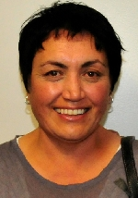
Trustees Chair Report
25 April 2017

Alayna Watene

We will remember them
Today is ANZAC Day. All around our country and also Australia, people will be gathering to commemorate ANZAC Day and remember all of those loved ones who served and died at War. Two weeks ago we celebrated Easter, another time to remember and realise the true meaning of peace through our Saviour Jesus Christ and his Atonement for us. Last year in May we ended our AGM with a walk around the urupa to celebrate mothers day and remember those passed on. We sang songs and remembered their love. May we always remember and be mindful of those of our loved ones who have passed on, who were once here at this marae, working hard for the future. May we also remember the work we do and how it will impact positively on our future generations.
Acknowledgements
On behalf of our Marae Trustees, I would like to thank each and every one of you for your support and for being here today. I want to acknowledge the Marae Committee for the work they have done to keep the marae functioning well. Improvements to the marae have not gone unnoticed and we are very thankful for the hardwork of those who come to the marae on a regular basis to ensure we keep our home fires burning and that we are prepared for when we are needed. Marae bookings have become frequent and we have held quite a few tangihanga, unveilings, weddings, birthdays, community dances, community shows, church gatherings and more. This is pleasing and its nice to have our marae being used.
Highlights of the Year
Strategic Planning
The highlight for me has been the coming together of our whanau to give input to our Strategic Plan. In August – October 2016 it was awesome to see us come together to share all of our thoughts about our vision, and strategic plan. We aren’t finished yet, but we are getting there.
Te Taiwhenua o Heretaunga
Tinaka Taito has been our elected Korongata Marae representative on Te Taiwhenua o Heretaunga Board for just over a year. We are pleased to have received our annual grant of $7,000.00. Over the year representatives from our marae were able to attend the Te Ture Paewhenua Wananga over four weekends. Shona Hopa, Dulcy Tihema, Sheree Te Aho, Sandra Tamati and Kathleen O’Shaughnessy attended from Korongata Marae and gained some valuable knowledge that has already been shared with the whanau during our Strategic Planning Sessions.

Te Runanga o Heretaunga Environment
Joella Brown is the Korongata marae representative on the Te Runanga o Heretaunga Environment Group. The cluster of Heretaunga marae representatives make up the subsidiary group that comes under Te Taiwhenua o Heretaunga. Matters concerning our environment are discussed at a Taiwhenua level which makes it easier to deal with in both a strong advocacy group as well as provide support across the table.
He Toa Takitini - Heretaunga Tamatea Post Settlement Trust
In 2015 He Toa Takitini settled the claims and we now have a Post Settlement Trust handling the current Post Settlement agreements and keeping our whānau updated. During this past year elections were held and I was nominated to represent our marae on the Trust.
Te Matatini
In February 2017 Ngati Kahungunu hosted the National Te Matatini Kapa Haka Competitions at Kahungunu Park. Tamatea Arikinui Kapa Haka group stayed at our marae and are very thankful for being able to stay and look after themselves. They were more grateful that we didn’t charge them ridiculous prices like other marae.

Our marae has received 60 new mattresses, pillows, sheets, and pillow cases as part of hosting a team at our marae. This is the outcome of a request that came from Te Kahu O Te Amorangi for sponsorship so our marae could be more capably prepared for hosting.

Marae Communications
The marae communications continues to improve. Our website www.korongatamarae.com and our face book page Korongata Marae are very active. Please email Ruth Wong if you want to receive panui ki te iwi. ruth@kahungunu.iwi.nz

KORONGATA MARAE
Finance Report
25 April 2017

Ryan Watene

KORONGATA MARAE AGM FINANCIAL REPORT
Year Ending 31 March 2017

Income and Expenditure Statement
OPENING BANK BALANCE - 1 April 2016 |  | $ 11,266.82
Incomings
He Toa Takitini PSGE | $ 10,000.00
Te Taiwhenua o Heretaunga | $ 7,000.00
Marae Booking | $ 6,500.00
Koha Received | $ 4,350.00
Interest Received | $ 998.91
Other Income | $ 150.00
 | $ 28,998.91
Outgoings
Maintenance | $ 9,225.00
Consultancy Fee | $ 4,792.78
Electricity | $ 3,097.53
Gas | $ 2,502.66
Fuel | $ 651.26
Koha Offered | $ 578.00
HDC Rates | $ 245.09
Other Expense | $ 1,200.00
Tractor Maintenance and Repair | $ 73.45
Capital Purchases | $ 3,400.00
 | $ 25,765.77
Surplus: |  | $ 3,233.14
CLOSING BANK BALANCE - 31 March 2017 |  | $ 14,499.96
NOTES:
Marae booking is calculated by subtracting the 'Kua hoki ke te Putea' subtotal ($4050) from
the 'Marae booking' subtotal ($10,550).

Term Deposit Investment Accounts
- Term Deposit 0791350-0001, processed 5 July 2016 $30,000.00
- Term Deposit 0791350-0002, processed 5 July 2016 $30,000.00
- Term Deposit 0791350-0003, processed 5 July 2016 $30,000.00

APPENDIX A:
 |  | LAST YEAR |  | THIS YEAR |  | BUDGET FOR NEXT YEAR
 |  | Ending 31 Mar 2016 |  | Ending 31 Mar 2017 |  | Ending 31 Mar 2018
OPENING BANK BALANCE |  | $ 24,677.05 |  | $ 11,266.82 |  | $ 14,499.96
Incomings
He Toa Takitini |  | $ - |  | $ 10,000.00 |  | $ -
Te Taiwhenua o Heretaunga |  | $ 7,000.00 |  | $ 7,000.00 |  | $ 7,000.00
Marae Booking |  | $ 5,750.00 |  | $ 6,500.00 |  | $ 5,000.00
Koha received |  | $ 1,850.00 |  | $ 4,350.00 |  | $ 1,700.00
Interest Received |  | $ 95.78 |  | $ 998.91 |  | $ 900.00
Other Income |  | $ 2,878.19 |  | $ 150.00 |  | $ 150.00
 |  | $ 17,573.97 |  | $ 28,998.91 |  | $ 14,750.00
Outgoings
Maintenance |  | $ - |  | $ 9,225.00 |  | $ 3,000.00
Consultancy Fee |  | $ - |  | $ 4,792.78 |  | $ -
Electricity |  | $ 4,135.31 |  | $ 3,097.53 |  | $ 3,500.00
Gas |  | $ 283.14 |  | $ 2,502.66 |  | $ 2,500.00
Fuel |  | $ 400.00 |  | $ 651.26 |  | $ 650.00
Koha offered |  | $ 310.00 |  | $ 578.00 |  | $ 800.00
HDC Rates |  | $ 576.45 |  | $ 245.09 |  | $ 576.00
Other Expense |  | $ 3,305.80 |  | $ 1,200.00 |  | $ 2,000.00
Tractor Maintenance and Repair |  | $ 4,963.50 |  | $ 73.45 |  | $ 1,000.00
Capital Purchases |  | $ 17,010.00 |  | $ 3,400.00 |  | $ -
 |  | $ 30,984.20 |  | $ 25,765.77 |  | $ 14,026.00
Deficit/Surplus: |  | $ (13,410.23) |  | $ 3,233.14 |  | $ 724.00
CLOSING BANK BALANCE |  | $ 11,266.82 |  | $ 14,499.96 |  | $ 15,223.96

KORONGATA MARAE ELECTIONS
INFORMATION ABOUT BEING A TRUSTEE AND THEIR OBLIGATIONS
25 April 2017

Excerpt from the Charter

MANAGEMENT

There shall be a Board of Trustees of the Marae, hereinafter referred to as “The Board”.
  - The Board shall comprise of a maximum of ten (10) and a minimum of seven (7) elected members. At least 80% of the Board shall be Tangata Whenua.

  - The Chairperson shall be appointed by the Board Members, who will serve for a period of three (3) years.

  - There shall be a Deputy Chairperson appointed by the Board members, who will serve for a period of up to three (3) years.

  - There shall be a Secretary appointed by the Board members, who will serve for a period of up to three (3) years.

  - All elected Board Members shall serve for a period of up to three (3) years, but may stand for re-election if so nominated.

  - Underpinning this structure all tuturu Maori Structures of Iwi, Hapu and Whanau. The special place of elders are acknowledged and that they are always present to offer guidance to the Board.

APPOINTMENT OF TRUSTEES

  - All New Zealand citizens are eligible for appointment as a Trustee unless they are one of the following persons:

- An undischarged bankrupt.
- A person who is subject to a Compulsory Treatment Order under Part II of the Mental Health Act 1992.
- A person convicted of any offence punishable by imprisonment for a term of six months or more, unless that sentence has been served or otherwise suffered the penalty imposed.

  - Nominations for Trustees will be accepted in writing on the day of the Annual General Meeting, or as such time and place that the Board may decide.

  - Nominations for Trustees will come from each block.

  - Nominators must have beneficial interest in specified block. The blocks are Korongata 1A, Korongata 1B, Korongata 1C, Korongata 2A, Korongata 2B1, Korongata 2B2, Korongata 2B3, Korongata 2B4, Te Awa O Te Atua 7A, Te Awa O Te Atua 7B2C.

  - All nominations must be seconded.

  - A nominee may not nominate or second him or herself.

  - Voting for election of nominees shall be by those present at a meeting and by a show of hands. Vacancies for the Board in any one-year shall be filled by the appropriate number of top polling nominees, subject to appointment by the Maori Land Court.

  - Elections of trustees shall be held at Annual General Meetings or at such time and place that the Board may decide. If the election of trustees is not at an Annual General Meeting, then there shall be a public notice in the local paper giving a minimum of one month’s notice of the specially called meeting.

  - At any Annual or Special General Meeting called there shall be minimum quorum of five (5) trustees of the Marae present before any voting is allowed. Beneficiaries are permitted in these meetings, but cannot vote at Board meetings.

TRUSTEES RESPONSIBILITIES

  - The Board shall safeguard the taonga and ensure that tikanga is observed at all times.

  - The Board shall be responsible for the efficient an effective running of the Marae.

  - All trustees have a duty to attend meetings called by the Chairperson. Trustees unable to attend meetings must tender their apologies to the Secretary (or representative prior to the meeting)

MEETINGS

  - The Board shall meet regularly, at any mutually agreed time, for the purposes of ongoing management of the Marae.

  - Annual General Meetings will be held within three (3) months of the end of the financial year. The purpose of the Annual General Meetings will be to present annual accounts, to elect new trustees if required, to present an account of the achievements of the year, to outline project objectives of the Board for the coming year, and to discuss any other business of the Marae as required by the meeting.

  - Notification of Annual General Meetings will be made through the local media one month prior to the meeting.

  - The Board may call special General Meetings at any one time as deemed necessary, for which one months notice will be given. A Special General Meeting must be called if the number of Trustees falls below five (5) for whatever reason.

DELEGATION OF AUTHORITY

  - The Chairperson may, if necessary, delegate Chairmanship of the Board to the Deputy Chairperson or if he/she is unavailable, to another trustee.

  - The Board may appoint sub-committees as necessary to oversee any aspect of the management of the Marae. Such sub-committees may comprise trustees and other beneficiaries.

  - The Board appoints the Marae committee to administer and oversee the day to day management of the Marae.

  - The financial accountability, records and accounts, is the responsibility of the Marae Committee and will from time to time, when advised by the Board allocate funds to the Board.

  - The Board appoints the Marae Committee to authorise activities on the Marae in accordance with Regulations nine (9) and ten (10) of the Maori Reservations Regulations 1994.

  - The Board appoints the Marae and Marae Maori Committee to apply for any and all funding and grants that may be available for the betterment of the Marae.

ADDITIONAL INFORMATION
What to expect if you are appointed
Being a Trustee is a big responsibility.
You need to:
- Have time to devote to the role and attend monthly meetings
- Play an active role in meetings - contribute, ask questions, request more information, and challenge the korero
- Maintain a high standard of conduct
- Understand the issues facing the marae, hapū, iwi, whenua, and our community at large.
- Be able to report to the whanau
Korongata Marae Land Blocks
- The land blocks at Korongata were aggregated on the 13th December 1988. According to the Maori Land Court it is called Te Awa O Te Atua Aggregation (Korongata Marae – ID 284954).
- According to our Charter, a nomination for trustee must come from one of the ten original blocks. The info on the following page (15) is to help you and your whānau with your nomination.
- Ideally whānau should have met with each other prior to the AGM on the 25 April 2017, so that the election process will be fairly quick.
- Please note, the Block Information (on page 15) was pulled together by Ruth Wong and added upon by Sabrina White, Daphne Kawana, Tatiana Greening and Kevin Tamati for the 2014 elections and is relevant today. This is a baseline document that we as a whānau can work on. The first three columns come from Maori Land Court documentation. The whānau names on the right were written in to help identify who’s who in the community. If you have any more information, please let me know. Ruth Wong 06 8798811 or 0272139547
- The charter also stipulates that the Board shall comprise of a maximum of ten (10) and a minimum of seven (7) elected members. At least 80% of the Board shall be Tangata Whenua. This means that 8 of the 10 trustees need to be tangata whenua and the other 2 nominations can be non tangata whenua, however the nomination needs to come from the block you are representing.
- After the election of the Trustees, the new Board of Trustees (if they see it necessary) will have the opportunity to appoint the Marae committee to administer and oversee the day to day management of the Marae.

MARAE LAND BLOCKS
Block Name | Area (ha) | Original Block owners | Some whānau names
Korongata 2B 1 | 0.285 | Hera Te Rori or Hape | Hapi, Onekawa
Korongata 2B 2 | 0.565 | Hereripine Tini  Honetere Paerata | Hapi, Onekawa
Korongata 2B 3 | 0.184 | Hone Puriri succeeded to Nikora Te Kere,  Pihikete Takarei | Takarei, Kawana, Puriri, Kamau
Korongata 2B 4 | 0.26 | Hariata Takarei  Morehu Takarei  Pihikete Takarei  Mereana Takarei | Takarei, Kawana
Korongata No 1A {Korongata Marae} | 0.6015 | Mereana Maurea  Mare Te Oti  Paora Nonoi | Hopa, Watene, Whakamoe
Korongata No 1B | 0.6156 | Anaru Puriri  Hone Puriri  Rawiri Kamau  Karaitiana Kamau  Kingi Kamau  Nikera Kamau  Eparaima Kamau  Iwa Kamau  Mare Kamau | Pere, Crawford, Kamau, Edwards, Henderson, Wainohu, Ferris, Puriri
Korongata No 1C | 0.3849 | Wairukuruku Maere | This is MOTHER Tata Wairukuruku Maere's inherited block from her father Maki Karaka.
Korongata No 2A | 0.283 | Rangi Parahi  Reupena Parahi  Mereana Parahi | Parahi
Te Awa O Te Atua 7B2C | 1.2442 | Rahui Rangihau  Nukunoa Rangi Hape  Peeti Onekawa  Hinekoia Kawana  Bella Eriatara  Waereti Gray  Mahiarangi Onekawa  Paul Onekawa | Onekawa  Kawana  Gray
Te Awa O Te Atua No 7A {Te Awa O Te Atua 7A} | 0.497 | Rangi Parahi  Reuben Parahi  Mereana Parahi | Parahi
MARAE LAND BLOCKS (MAP)

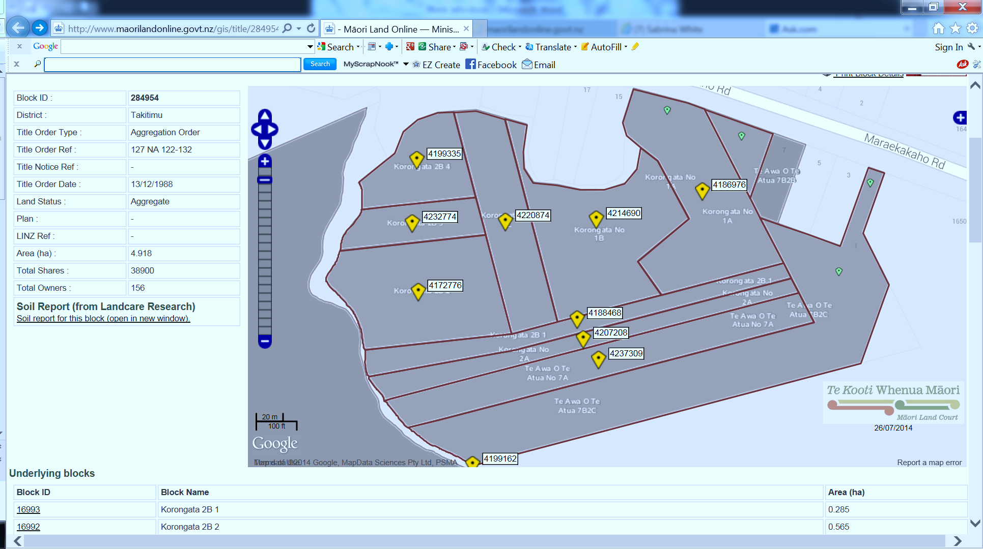

KORONGATA MARAE ELECTIONS
ELECTION PROCESS
25 April 2017

- Independent Election Officer Introduced (Ruth Wong)
- Election announced open
- Eligible Nominations received
- Nominator, Seconder and Nominee must be present at the hui.
- Nominations come from the blocks noted for re-election.
- Successful nominations will be recorded
- If more than one nomination is received for one block, whānau who affiliate to that block, who are present at the AGM/election meeting will vote. (Proxy votes are not accepted)
- Successful candidates will be announced and will kōrero
- Election declared closed.

KORONGATA MARAE ELECTIONS
ELECTION CHART
25 April 2017

Block Name | CURRENT TRUSTEE | NOMINATIONS | NEW TRUSTEE
Korongata 2B 1 | Barney Tihema
Korongata 2B 2 | Laura Kele | Laura was elected in May 2016. There is no need for a re-election at this AGM
Korongata 2B 3 | Tatiana Greening
Korongata 2B 4 | Shona Chadwick
Korongata No 1A {Korongata Marae} | Alayna Watene
Korongata No 1B | Jaamin Pere
Korongata No 1C | Teresa Susie Morrison
Korongata No 2A | Kathleen O’Shaughnessy
Te Awa O Te Atua 7B2C | Te Whare Tihema
Te Awa O Te Atua No 7A {Te Awa O Te Atua 7A} | Steven Robert Tipu

Independent Election Officer: Ruth Wong

KORONGATA MARAE CONTACTS
Communications
25 April 2017

KORONGATA MARAE
Korongata Marae is a Māori Reservation for the purposes of a Marae, a place of historic interest.

ADDRESS
9 Maraekakaho Road, Bridge Pa
PO Box 1417, Hastings
- Marae Committee Chair: Ryan Watene 0221511788 ryanwatene@hotmail.com
- Marae Committee Secretary: Michelle Ferris 0210558911 mjferris52@gmail.com
- Marae Communications & Booking Officer: Ruth Wong 0272139547
- Marae Kitchen Facilities: irene De Theirry 0226761103 irenedetheirry@gmail.com
korongata@gmail.com | www.korongatamarae.com
Find us on Facebook: Korongata Marae

