KORONGATA MARAE ELECTIONS
INFORMATION PAPER
25 April 2017

Tena koe,
You are reading this because you are interested in the Korongata Marae Trustee Elections 2017. The following information will help you understand the obligations of a trustee so you understand more clearly what your responsibilities are before you commit to nominating someone or if you are wanting to be nominated. Please read the following information.

Excerpt from the Korongata Marae Charter

MANAGEMENT

There shall be a Board of Trustees of the Marae, hereinafter referred to as “The Board”.
  - The Board shall comprise of a maximum of ten (10) and a minimum of seven (7) elected members. At least 80% of the Board shall be Tangata Whenua.

  - The Chairperson shall be appointed by the Board Members, who will serve for a period of three (3) years.

  - There shall be a Deputy Chairperson appointed by the Board members, who will serve for a period of up to three (3) years.

  - There shall be a Secretary appointed by the Board members, who will serve for a period of up to three (3) years.

  - All elected Board Members shall serve for a period of up to three (3) years, but may stand for re-election if so nominated.

  - Underpinning this structure all tuturu Maori Structures of Iwi, Hapu and Whanau. The special place of elders are acknowledged and that they are always present to offer guidance to the Board.

APPOINTMENT OF TRUSTEES

  - All New Zealand citizens are eligible for appointment as a Trustee unless they are one of the following persons:

- An undischarged bankrupt.
- A person who is subject to a Compulsory Treatment Order under Part II of the Mental Health Act 1992.
- A person convicted of any offence punishable by imprisonment for a term of six months or more, unless that sentence has been served or otherwise suffered the penalty imposed.

  - Nominations for Trustees will be accepted in writing on the day of the Annual General Meeting, or as such time and place that the Board may decide.

  - Nominations for Trustees will come from each block.

  - Nominators must have beneficial interest in specified block. The blocks are Korongata 1A, Korongata 1B, Korongata 1C, Korongata 2A, Korongata 2B1, Korongata 2B2, Korongata 2B3, Korongata 2B4, Te Awa O Te Atua 7A, Te Awa O Te Atua 7B2C.

  - All nominations must be seconded.

  - A nominee may not nominate or second him or herself.

  - Voting for election of nominees shall be by those present at a meeting and by a show of hands. Vacancies for the Board in any one-year shall be filled by the appropriate number of top polling nominees, subject to appointment by the Maori Land Court.

  - Elections of trustees shall be held at Annual General Meetings or at such time and place that the Board may decide. If the election of trustees is not at an Annual General Meeting, then there shall be a public notice in the local paper giving a minimum of one month’s notice of the specially called meeting.

  - At any Annual or Special General Meeting called there shall be minimum quorum of five (5) trustees of the Marae present before any voting is allowed. Beneficiaries are permitted in these meetings, but cannot vote at Board meetings.

TRUSTEES RESPONSIBILITIES

  - The Board shall safeguard the taonga and ensure that tikanga is observed at all times.

  - The Board shall be responsible for the efficient an effective running of the Marae.

  - All trustees have a duty to attend meetings called by the Chairperson. Trustees unable to attend meetings must tender their apologies to the Secretary (or representative prior to the meeting)

MEETINGS

  - The Board shall meet regularly, at any mutually agreed time, for the purposes of ongoing management of the Marae.

  - Annual General Meetings will be held within three (3) months of the end of the financial year. The purpose of the Annual General Meetings will be to present annual accounts, to elect new trustees if required, to present an account of the achievements of the year, to outline project objectives of the Board for the coming year, and to discuss any other business of the Marae as required by the meeting.

  - Notification of Annual General Meetings will be made through the local media one month prior to the meeting.

  - The Board may call special General Meetings at any one time as deemed necessary, for which one months notice will be given. A Special General Meeting must be called if the number of Trustees falls below five (5) for whatever reason.

DELEGATION OF AUTHORITY

  - The Chairperson may, if necessary, delegate Chairmanship of the Board to the Deputy Chairperson or if he/she is unavailable, to another trustee.

  - The Board may appoint sub-committees as necessary to oversee any aspect of the management of the Marae. Such sub-committees may comprise trustees and other beneficiaries.

  - The Board appoints the Marae committee to administer and oversee the day to day management of the Marae.

  - The financial accountability, records and accounts, is the responsibility of the Marae Committee and will from time to time, when advised by the Board allocate funds to the Board.

  - The Board appoints the Marae Committee to authorise activities on the Marae in accordance with Regulations nine (9) and ten (10) of the Maori Reservations Regulations 1994.

  - The Board appoints the Marae and Marae Maori Committee to apply for any and all funding and grants that may be available for the betterment of the Marae.

ADDITIONAL INFORMATION
What should I expect if I am appointed? Being a Trustee is a big responsibility.
You need to:
- Have time to devote to the role and attend monthly meetings
- Play an active role in meetings - contribute, ask questions, request more information, and challenge the korero
- Maintain a high standard of conduct
- Understand the issues facing the marae, hapū, iwi, whenua, and our community at large.
- Fill in the right nomination form.
Korongata Marae Land Blocks
- The land blocks at Korongata were aggregated on the 13th December 1988. According to the Maori Land Court it is called Te Awa O Te Atua Aggregation (Korongata Marae – ID 284954).
- According to our Charter, a nomination for trustee must come from one of the ten original blocks.
- Ideally whānau should have met with each other prior to the AGM/Election Hui on the 25th April, so that the election process will be fairly quick.
- Please note, the Block Information (which follows) was pulled together by Ruth Wong and added upon by Sabrina White, Daphne Kawana, Tatiana Greening and Kevin Tamati for the 2014 AGM election and is still relevant today.
- The block chart also includes current trustees.
- The charter also stipulates that the Board shall comprise of a maximum of ten (10) and a minimum of seven (7) elected members. At least 80% of the Board shall be Tangata Whenua. This means that 8 of the 10 trustees need to be tangata whenua and the other 2 nominations can be non tangata whenua, however the nomination needs to come from the block you are representing.
- After the election of the Trustees, the new Board of Trustees (if they see it necessary) will have the opportunity to appoint the Marae committee to administer and oversee the day to day management of the Marae.

MARAE LAND BLOCK CHART
Block Name | Area (ha) | Original Block owners | Current Trustee
Korongata 2B 1 | 0.285 | Hera Te Rori or Hape | Barney Tihema
Korongata 2B 2 | 0.565 | Hereripine Tini, Honetere Paerata | Laura Kele
Korongata 2B 3 | 0.184 | Hone Puriri succeeded to Nikora Te Kere, Pihikete Takarei | Tatiana Greening
Korongata 2B 4 | 0.26 | Hariata Takarei, Morehu Takarei, Pihikete Takarei, Mereana Takarei | Shona Chadwick
Korongata No 1A {Korongata Marae} | 0.6015 | Mereana Maurea, Mare Te Oti  Paora Nonoi | Alayna Watene
Korongata No 1B | 0.6156 | Anaru Puriri, Hone Puriri, Rawiri Kamau, Karaitiana Kamau, Kingi Kamau, Nikera Kamau, Eparaima Kamau, Iwa Kamau, Mare Kamau | Jaamin Pere
Korongata No 1C | 0.3849 | Wairukuruku Tata Maere | Teresa Susie Morrison
Korongata No 2A | 0.283 | Rangi Parahi, Reupena Parahi, Mereana Parahi | Kathleen O’Shaughnessy
Te Awa O Te Atua 7B2C | 1.2442 | Rahui Rangihau, Nukunoa Rangi Hape  Peeti Onekawa, Hinekoia Kawana  Bella Eriatara, Waereti Gray  Mahiarangi Onekawa, Paul Onekawa | Te Whare Tihema
Te Awa O Te Atua No 7A {Te Awa O Te Atua 7A} | 0.497 | Rangi Parahi, Reuben Parahi, Mereana Parahi | Steven Robert Tipu

MARAE LAND BLOCKS (MAP)

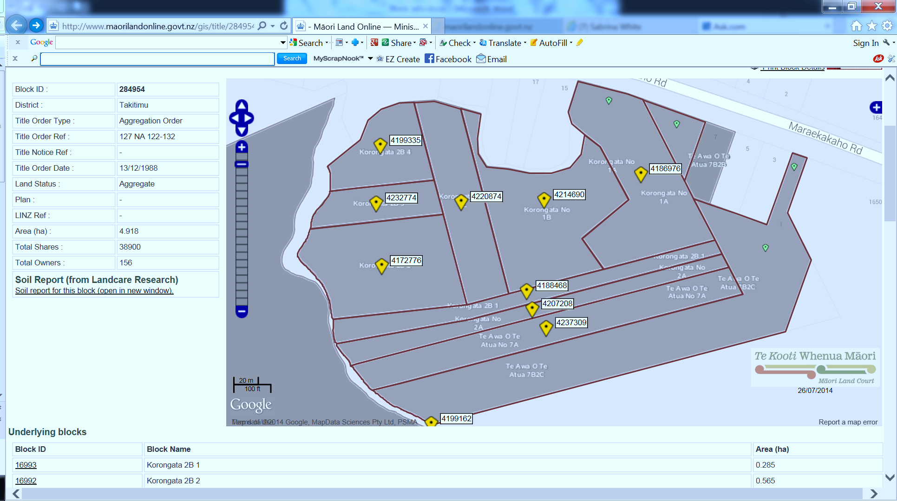

KORONGATA MARAE ELECTIONS
ELECTION PROCESS
25 April 2017

- Independent Election Officer Introduced
- Election announced open
- Eligible Nominations received
- Nominator, Seconder and Nominee must be present at the hui.
- Nominations come from the blocks noted for re-election.
- Successful nominations will be recorded
- If more than one nomination is received for one block, whānau who affiliate to that block, who are present at the AGM/election meeting will vote. (Proxy votes are not accepted)
- Successful candidates will be announced and will kōrero
- Election declared closed.

Please use the approved nomination form. These will be available on the day of the AGM/Re-election 25 April 2017.

